The University of Azad Jammu and Kashmir, Muzaffarabad



Jawahir Ali
2024-SE-34
Computer Networks
Engr. Dr. Asma Javaid
Lab 02
Introduction to Computer Networks & Cisco Packet tracer
-Simple LAN-
Department Of Software Engineering
PART-A Network Topology Creation.
CREATING AND TEST SIMPLE LAN IN CISCO PACKET TRACER

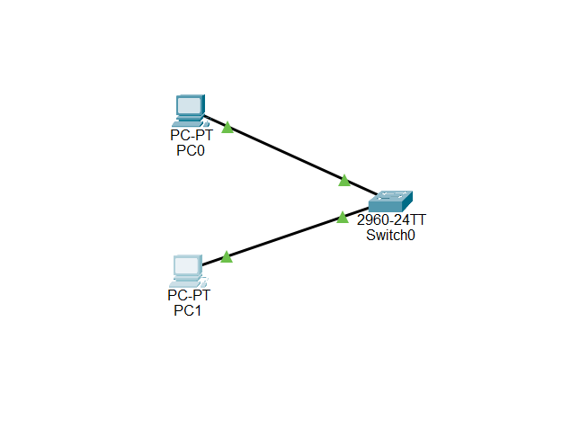

Figure 1

Description: 1. Two PCs are connected to Switch through wires.

PART-B IP Address Configuration.

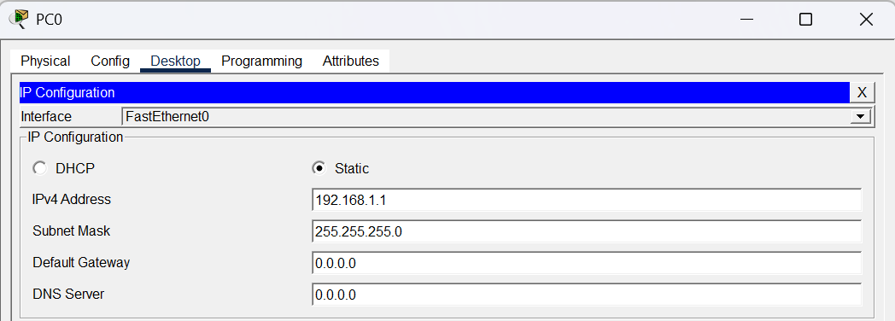
FOR PC0
Figure 2:IP Configuration for PC0

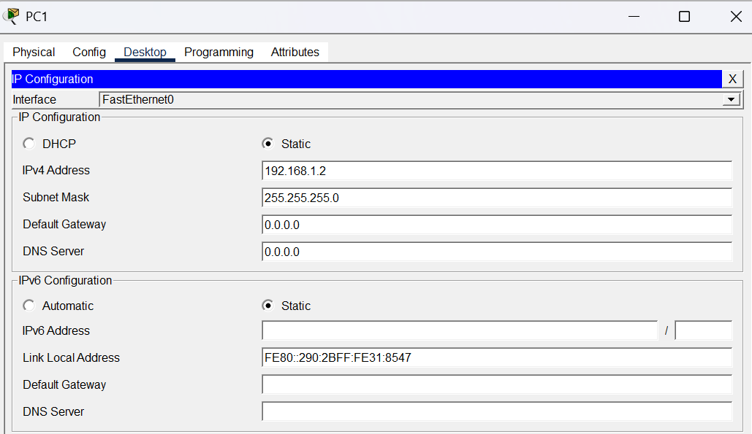
FOR PC1
Figure 3: IP Configuration for PC1

Description: 1. Configuration of IP address to both PCs.

PART-C Network Testing using CLI commands.

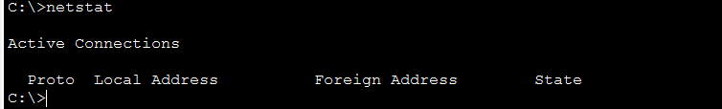
1.netstat Display active connection and statistics.
Figure 4:Show active connections

2.ipconfig Display the IP Configuration of PC.
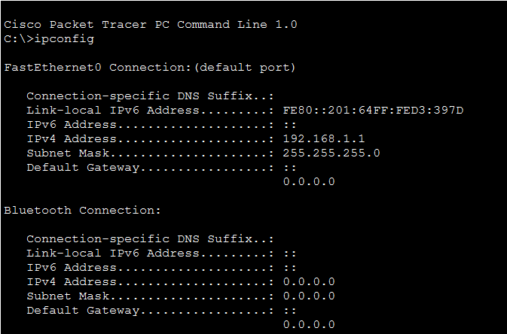

Figure 5: Display IP configuration

3.ping Test connectivity between two devices.
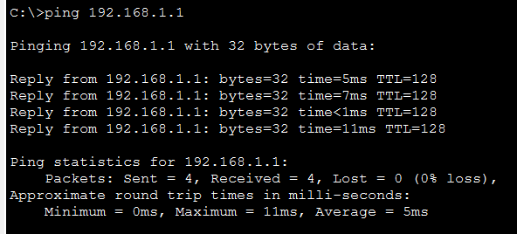
Figure 6: Connectivity between two devices

4.tracert Show the path taken by packets.
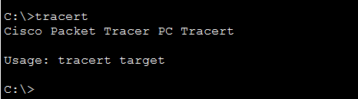
Figure 7

5.arp -a Display ARP table (MAC address mapping).

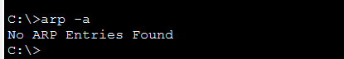
Figure 8
Description: In this part, different Command Line Interface (CLI) networking commands were used to test and verify the network connectivity between the devices. Commands such as netstat, ipconfig, ping, tracert, and arp -a were executed to display network configuration details, check active connections, verify communication between PCs, observe the route taken by packets, and display the MAC address mapping in the ARP table.

